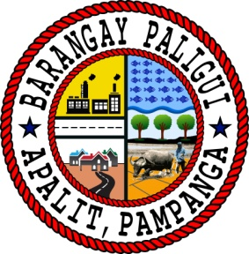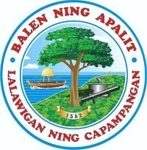Republic of the Philippines

Region III

Province of Pampanga

Municipality of Apalit

**BARANGAY PALIGUI**

*Office of the Sangguniang Kabataan*

**AN EXCERPT FROM THE MINUTES OF THE MEETING DURING THE 6th SANGGUNIANG KABATAAN REGULAR SESSION HELD ON APRIL 14 2024,**

**11:00 A.M. AT BARANGAY PALIGUI SESSION HALL, APALIT, PAMPANGA.**

**Present:**

Hon. Arjay L. Saclao - SK Chairperson/

Presiding Officer

Hon. Paul C. Alfonso - SK Kagawad

Hon. Ervie R. Dizon - SK Kagawad

Hon. Angelo F. Umali - SK Kagawad

Hon. Chin Jean M. Meneses - SK Kagawad

Hon. Ian Jaspher C. Villarico - SK Kagawad

Hon. Michaela Lorine R. Amparo - SK Kagawad

Hon. Karen B. Bautista - SK Kagawad

Mr. Kenneth D. Bautista - SK Secretary

Ms. Angel Mae B. Bautista - SK Treasurer

**Absent:**

*x------------------------------------------------------------------------------------------------------------------x*

**RESOLUTION NO. 03**

**Series of 2024**

**A RESOLUTION APPROVING THE COMPREHENSIVE BARANGAY YOUTH DEVELOPMENT PLAN (CBYDP) FOR THE CUMULATIVE CALENDAR YEAR FROM 2024-2026 OF BARANGAY PALIGUI, APALIT, PAMPANGA**

**WHEREAS,** Republic Act No. 10742 also known as the Sangguniang Kabataan Reform Act of 2015 and its implementing rules and regulations, the SK, in consultation with the concurrence of the Katipunan ng Kabataan, shall formulate a three (3) year rolling plan, which shall be known as Comprehensive Barangay Youth Development Plan (CBYDP);

**WHEREAS,** the Comprehensive Barangay Youth Development Plan (CBYDP) shall be aligned with the Philippine Youth Development Plan (PYDP) and the Local Youth Development Plan (LYDP) of the Province and Municipality;

**WHEREAS,** the CBYDP shall give priority to the programs, projects, and activities that will promote and ensure the equitable access to the quality education, environmental protection climate change adaption, disaster risk reduction and resiliency, youth employment and livelihood, health, including health service and adolescent, sexual and reproductive health, anti-drug abuse, gender sensitivity, sports development and capacity building which emphasizes leadership training.

**WHEREAS,** the Comprehensive Barangay Youth Development Plan (CBYDP) shall serve as the legal basis for the preparation of the Annual Barangay Youth Investment Plan (ABYIP);

**NOW THEREFORE, BE IT RESOLVED, AS IT IS HEREBY RESOLVED,** to approve the Comprehensive Barangay Youth Development Plan for the Cumulative Calendar Year from 2024-2026 of Barangay Paligui, Apalit, Pampanga.

**RESOLVED FURTHER.** that copy of this resolution be given to the Local Youth Development Office of Apalit, Pampanga, Municpal Office of the Interior and Local Government, and Municipal Budget Office for their information and record.

x------------------------------------------------------------------------------------------------------------------x

**ADOPTED,** this 14th day of April 2024 at Barangay Paligui, Apalit, Pampanga.

Attested by:

**MR. KENNETH D. BAUTISTA**

SK Secretary

Approved by:

**HON. ARJAY L. SACLAO**

SK Chairperson

**HON. PAUL C. ALFONSO HON. ERVIE R. DIZON**

SK Kagawad SK Kagawad

**HON. ANGELO F. UMALI HON. CHIN JEAN M. MENESES**

SK Kagawad SK Kagawad

**HON. IAN JASPER C. VILLARICO HON. MICHAELA LORINE R. AMPARO**

SK Kagawad SK Kagawad

**HON. KAREN B. BAUTISTA**

SK Kagawad